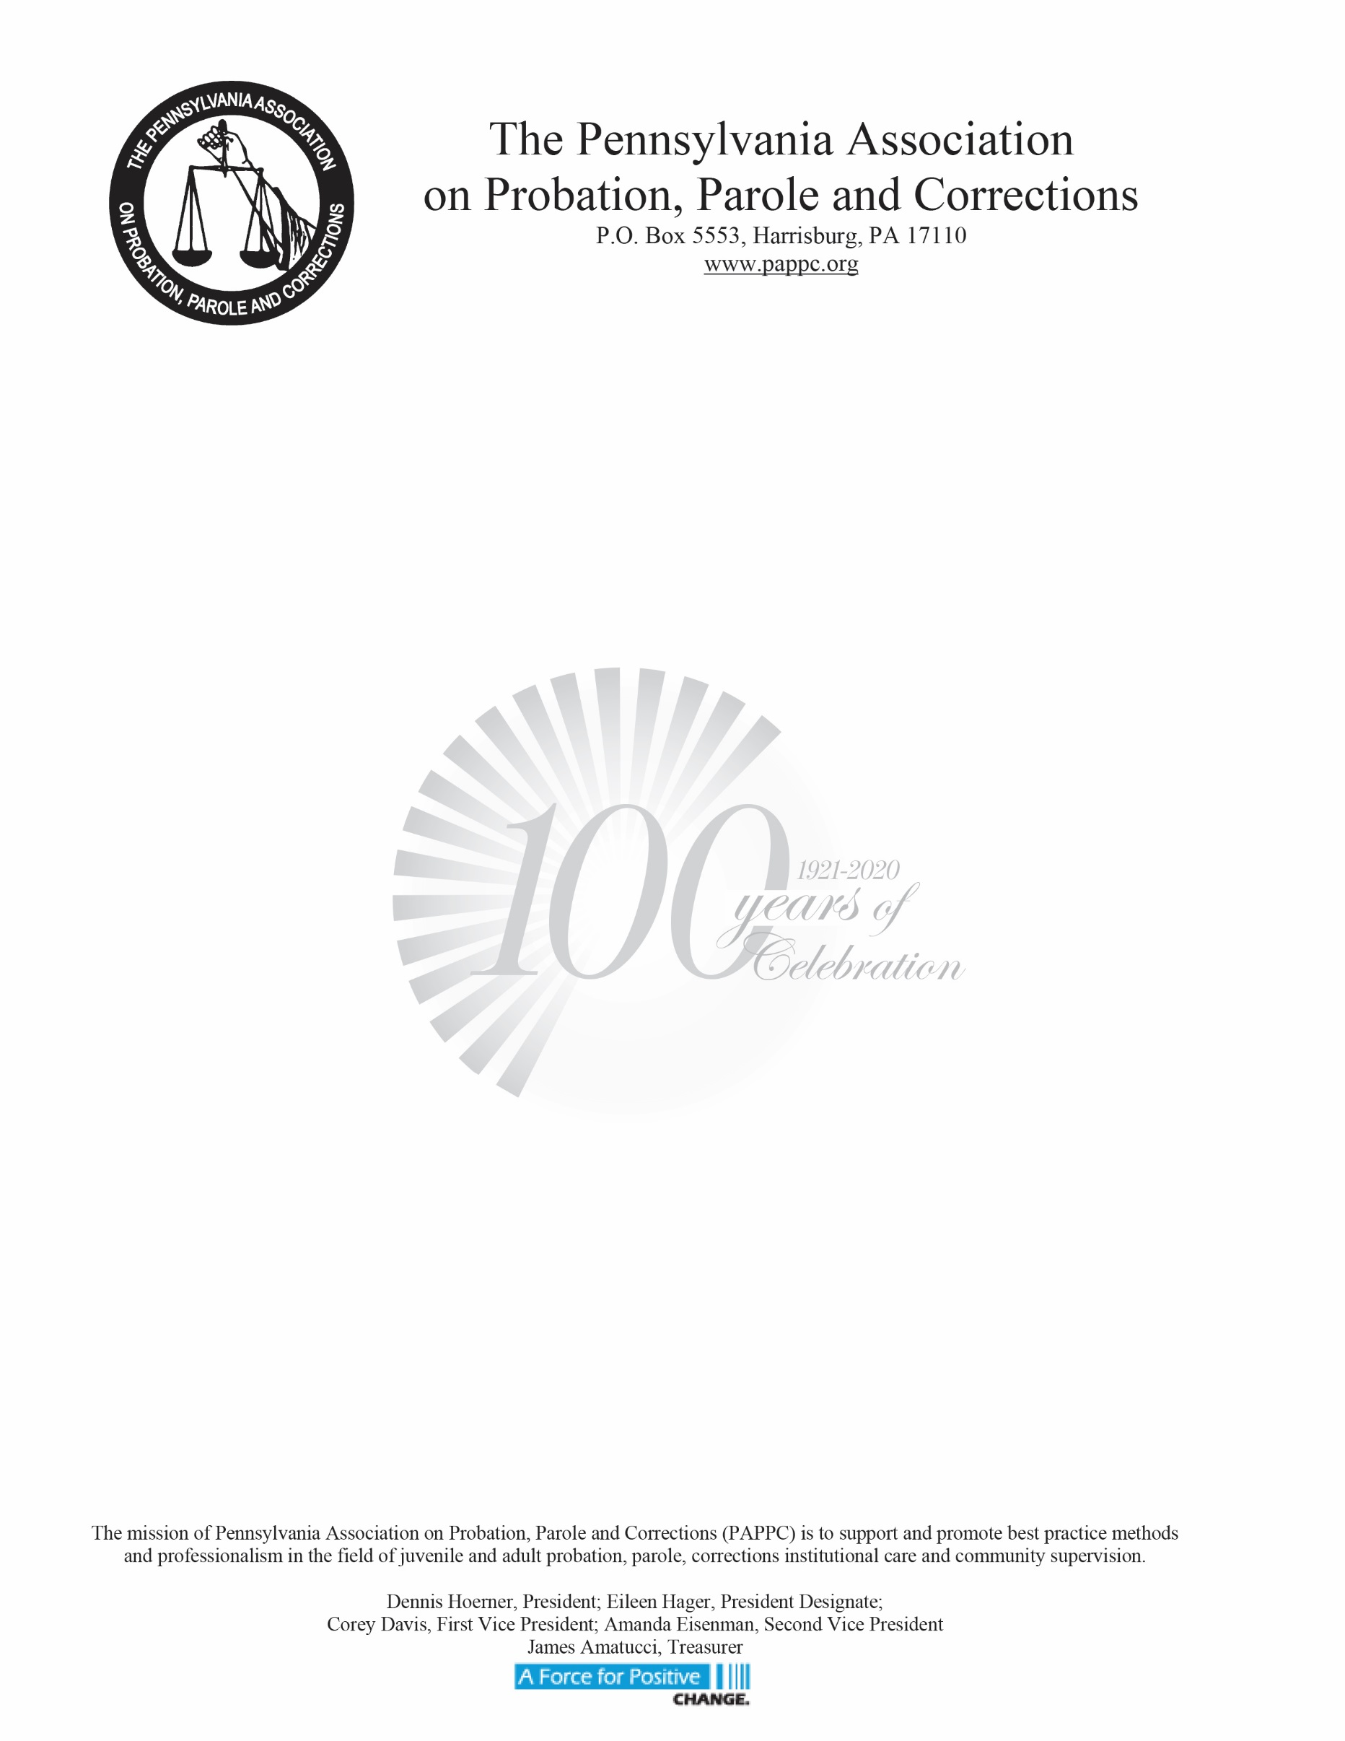

**PAPPC Fall Regional Training**

**Autism and the Justice System**

**Presenter: Kate Hooven**

**Friday, October 25th, 2019**   
9:30am- 3:30pm (registration begins @ 9:00am)

Westmoreland County Courthouse

2 North Main Street, Commissioner’s Meeting Room

Greensburg, PA 15601  
  
**Wednesday, October 30th, 2019**  
9:30am-3:30pm (registration begins @ 9:00am)  
DOC Training Academy

N. Market Street

Elizabethtown, PA 17022

**Friday, November 1st, 2019**  
9:30am-3:30pm (registration begins @ 9:00am)

Region 1 Office

261 Old York Road, 4th Floor, Suite 420

Jenkintown, PA 19046

**PAPPC Members – Free**

**Non-PAPPC Members - $25.00 each**

**Non-PAPPC DOC/BCC Employees – Free (limited amount at each venue)**

Ms. Hooven will use her former background in PA’s Juvenile Justice System, and her passion for advocating for children and adults living with autism, to train probation officers, police officers, attorneys, judges, correctional officers and others employed in the justice system and to raise awareness of the impact an autism diagnosis has on those individuals involved in our juvenile and criminal justice systems.

Please visit [www.PAPPC.Org](https://gcc01.safelinks.protection.outlook.com/?url=http%3A%2F%2Fwww.PAPPC.Org&data=02%7C01%7Cdhoerner%40pa.gov%7Ca8e9844169a04440cec208d73c5d8544%7C418e284101284dd59b6c47fc5a9a1bde%7C0%7C0%7C637044244675809350&sdata=w%2FHUNa5jX9ekQob0m2DRX6QR%2BMcMqaWC1M3qiQTGHAw%3D&reserved=0) to register. Registration deadline **October 18th, 2019**.