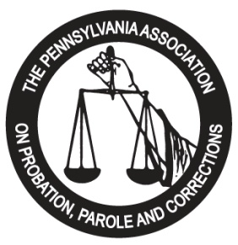

Sponsorship Opportunities

ARE YOU INTERESTED IN HAVING YOUR COMPANY SPONSOR AN EVENT OR ACTIVITY AT THE
2023 PAPPC TRAINING INSTITUTE AT THE KALAHARI RESORTS POCONOS?
WE ARE LOOKING FOR SPONSORS AND CO-SPONSORS FOR THE FOLLOWING:

Key Note Opening Speaker  Plenary Session Speaker  Reception – Sunday | $2,500.00  $750.00  $1,000.00
Mid-Morning Break - Monday | $750.00
Awards Luncheon - Monday | $1,000.00
Afternoon Break - Monday | $750.00
All Day Coffee and Tea Service | $1,000.00
Mid-Morning Break - Tuesday | $750.00
Awards Luncheon - Tuesday | $1,000.00
Afternoon Break – Tuesday | $750.00
Closing Session Speaker - Wednesday | $1,000.00
Vendor Sponsorship – multiple available | $500.00
1/4 page Program Ad in booklet* | $100.00
1/2 page Program Ad in booklet* | $175.00
Full page Program Ad in booklet* | $350.00
Rear Cover Program Ad - (1 available) | $550.00
Vendor Sponsorship -15 MINUTE PRODUCT DEMO* | $500.00
Vendor Sponsorship -30 MINUTE PRODUCT DEMO* | $750.00
Vendor Sponsorship -45 MINUTE PRODUCT DEMO* | $1,000.00
Other Sponsorship | ________
* Please forward your ad in a PDF File format.
*Product demo’s will be included as part of the conference agenda!
Full and partial sponsorships of items are available!
Contact:
Darrell Kirkbride, PAPPC Exhibitor Chair…..….…dkirkbride@renewalinc.com

