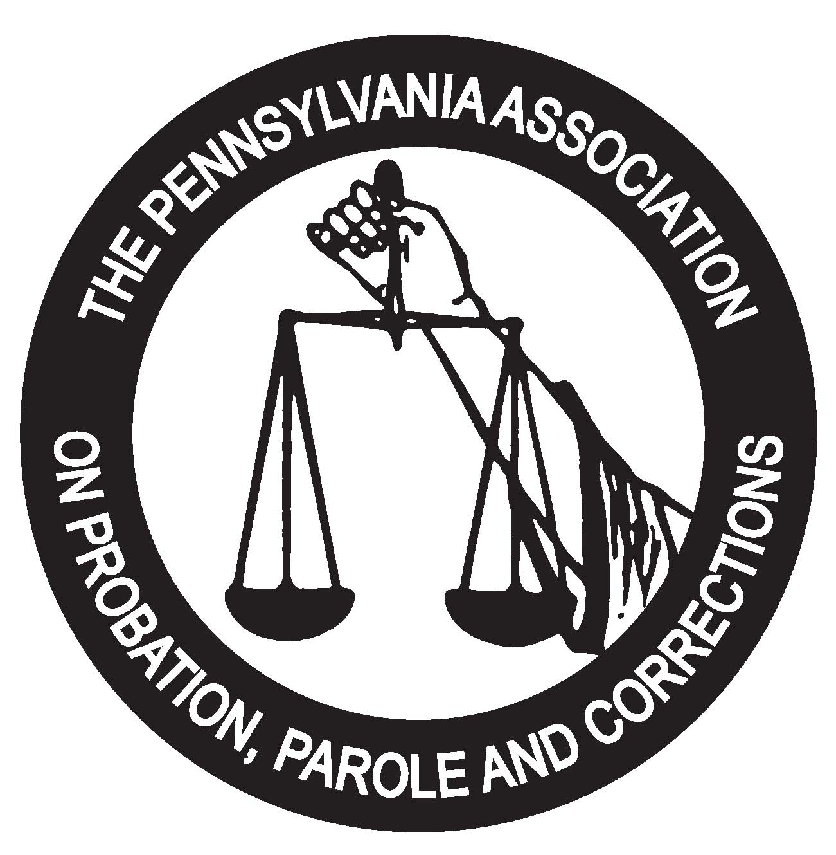
The Pennsylvania Association on Probation, Parole and Corrections
P.O. BOX 5553 • HARRISBURG, PA 17110
www.pappc.org

DATE: February 1, 2023

TO: PAPPC Members

FROM: PAPPC Awards Committee

RE: 2023 PAPPC Awards Program

The Pennsylvania Association on Probation, Parole and Corrections is pleased to announce that nominations are now being accepted for its 2023 Awards Program. This year, award categories for which you, or your co-workers, may be eligible include:

JUVENILE JUSTICE PROFESSIONAL OF THE YEAR

ADULT CRIMINAL JUSTICE PROFESSIONAL OF THE YEAR

Please review the attached nomination form for definitions of award categories and nomination criteria. PAPPC believes it is essential to honor individuals, companies, or facilities who have made significant contributions to Pennsylvania’s Criminal and Juvenile Justice Systems. Please take this opportunity to make a nomination for these awards. Nominations must be postmarked by April 15, 2023. Award winners will be honored at the PAPPC 101st Annual Training Institute; on Tuesday, May 23, 2023, at the Kalahari Resort Poconos, 250 Kalahari Blvd, Pocono Manor, PA 18349.
Thank you for your interest and support of the 2023 PAPPC Awards Program.
Definitions of Award Categories
(Nominees need NOT be active members of PAPPC)

Juvenile Justice Professional of the Year

A professional who is employed in Pennsylvania by a county juvenile probation department and supervises juveniles alleged or adjudicated delinquent or an agency which provides services to juvenile offenders referred by juvenile courts, including, but not limited to, detention centers, residential facilities operated privately or by the Department of Public Welfare, and out-patient or day treatment programs.

Adult Criminal Justice Professional of the Year

A professional who is employed in Pennsylvania by an agency at the federal, state or local level which provides supervision to adults on probation or parole or is employed in an adult correctional institutional facility, including county jails, state, and federal prisons within Pennsylvania, employed in the field of community corrections, including private contract facilities or vendors who contract with state, federal or county governments, employed by county, state, and federal operated half-way houses or community corrections centers within the state of Pennsylvania.

Nomination Criteria

1. Nominee must be employed in the award category at the time the nomination is submitted.
(Date of submission is defined as the date of the nomination letter’s postmark.)
2. Nominations must be postmarked no later than April 15, 2023.
3. Winners from previous years may not be re-nominated.
4. Nominations should be written so the nominee’s identity cannot be discerned by reading the narrative. The name and agency of the nominee should only be written the cover page.
5. Nominations should be submitted on this nomination form.
2023 PAPPC AWARDS PROGRAM

PLEASE CHECK THE APPROPRIATE NOMINATION CATEGORY

_______ JUVENILE JUSTICE PROFESSIONAL OF THE YEAR

_______ ADULT CRIMINAL JUSTICE PROFESSIONAL OF THE YEAR

_____________________________________
Name of Nominee

__________________________________
Agency

__________________________________
Phone

____________________________
Telephone Number of Contact Person

_____________________________________
Name of contact person

_____________________________________
Relationship to nominee

_____________________________________
Address of contact person

SUBMITT BY: April 15, 2023

RETURN TO: Tonuia Smith
Smithto@westmoreland.edu
or

PAPPC - Awards
P.O. Box 1603
Greensburg, PA 15601
2023 PAPPC AWARDS PROGRAM

Nomination

I. Describe (do not list) a significant experience, the qualities, skills, and abilities which has contributed to the nominees’ professional development. Include examples of initiative, creativity, leadership, management skills, organizational ability, and other personal attributes they exhibit.

- 1 -
(Continue on page 2 if necessary.)

- 2 –

(Continue on page 3 if necessary.)

- 3 -

