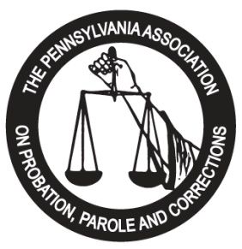

This serves as the contractual agreement between the Pennsylvania Association on Probation, Parole and Corrections (PAPPC), and your agency. PAPPC agrees to provide exhibit space and/or advertisements for your company at the 2026 Training Institute to be held at The Imperial Event Center, 26 E. Chestnut Street, Lancaster, PA, 17602 from May 17 - May 20, 2026, according to the specifications listed below:

Exhibit Booth: $ 750.00* ______________

INTERNAL USE ONLY

DATE RECEIVED:
__________________

BOOTH NUMBER:
__________________
$ 800.00** ______________
Program Journal Ad:
-Full page: $ 350.00 ______________
-Half page: $ 175.00 ______________
-Quarter page: $ 100.00 ______________
-Rear Cover $ 550.00 ______________
Sponsorships: (see attached) ______________
Total: ______________

Authorized Signature: Date:

Please PRINT:
Name/Title
* Exhibitor Registration postmarked and payment received on or before April 17, 2026
** Exhibitor Registration postmarked and payment received on or after April 18, 2026

All checks should be made payable to: PAPPC. Electronic payment options via PayPal/Venmo available upon request.
Please complete below information, as you would like it to appear in our conference program. Conference registrations for two (2) company representatives are included in the above exhibit booth pricing.

Company Name:

Forward Registration Forms, Checks and Electronic Ads to:

2026 Exhibitor Chair
Darrell Kirkbride/PAPPC
P.O. Box 1603
Greensburg, PA 15601

Address:

Phone Number: Fax Number:

Representative(s):

E-Mail Address:

Product Line/Services:

DO YOU REQUIRE ELECTRICITY FOR YOUR BOOTH? __Y __N

