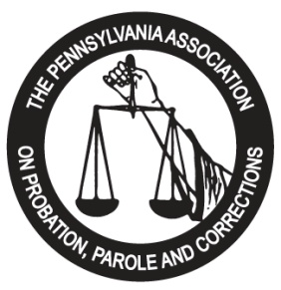

This serves as the contractual agreement between the Pennsylvania Association on Probation, Parole and Corrections (PAPPC), and your agency. PAPPC agrees to provide exhibit space and/or advertisements for your company at the 2024 Training Institute to be held at The Landing Hotel at Rivers Casino, 757 Casino Drive, Pittsburgh, PA, 15212 from May 19 - May 22, 2024, according to the specifications listed below:

Exhibit Booth: $ 650.00* ______________

INTERNAL USE ONLY

DATE RECEIVED:
__________________

BOOTH NUMBER:
__________________
$ 700.00** ______________
Program Journal Ad:
-Full page: $ 350.00 ______________
-Half page: $ 175.00 ______________
-Quarter page: $ 100.00 ______________
-Rear Cover $ 550.00 ______________
Sponsorships: (see attached) ______________
Total: ______________

Authorized Signature: Date:

Please PRINT:
Name/Title
* Exhibitor Registration postmarked and payment received on or before April 14, 2024
** Exhibitor Registration postmarked and payment received on or after April 15, 2024

All checks should be made payable to: PAPPC. Electronic payment options available upon request.
Please complete below information, as you would like it to appear in our conference program. Conference registrations for two (2) company representatives are included in the above exhibit booth pricing.

Company Name:

Forward Registration Forms, Checks and Electronic Ads to:

2024 Exhibitor Chair
Darrell Kirkbride/PAPPC
P.O. Box 1603
Greensburg, PA 15601

Address:

Phone Number: Fax Number:

Representative(s):

E-Mail Address:

Product Line/Services:

DO YOU REQUIRE ELECTRICITY FOR YOUR BOOTH? __Y __N

