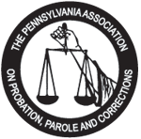

The Pennsylvania Association
on Probation, Parole and Corrections
P.O. Box 1603 Greensburg , PA
www.pappc.org

Save the Date
The 2024 PAPPC Training Institute and Conference
“Building Bridges: Transforming Communities, Corrections, and Re-Entry Supervision”
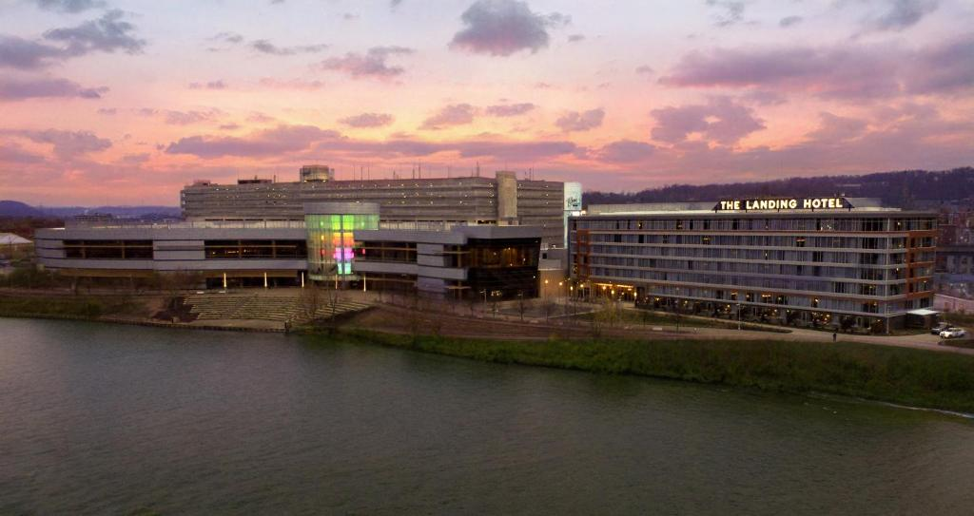

May 19th, 2024 to May 22nd, 2024
The Landing Hotel at Rivers Casino
757 Casino Drive Pittsburgh, PA 15212

