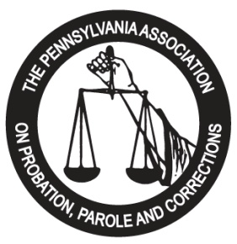

Sponsorship Opportunities

ARE YOU INTERESTED IN HAVING YOUR COMPANY SPONSOR AN EVENT OR ACTIVITY AT THE
2022 PAPPC TRAINING INSTITUTE AT THE HILTON HOTEL IN HARRISBURG, PA
WE ARE LOOKING FOR SPONSORS AND CO-SPONSORS FOR THE FOLLOWING:

Key Note Opening Speaker  Plenary Session Speaker  Reception – Sunday | $2,500.00  $750.00  $1,000.00
Mid-Morning Break - Monday | $750.00
Awards Luncheon - Monday | $1,000.00
Afternoon Break - Monday | $750.00
All Day Coffee and Tea Service | $1,000.00
Mid-Morning Break - Tuesday | $750.00
Awards Luncheon - Tuesday | $1,000.00
Afternoon Break – Tuesday | $750.00
Closing Session Speaker - Wednesday | $1,000.00
Vendor Sponsorship – multiple available | $500.00
1/4 page Program Ads in booklet* | $75.00
1/2 page Program Ads in booklet* | $150.00
Full page Program Ads in booklet* | $300.00
Rear Cover - (only 1 available) | $700.00
General Sponsorship – 15 MINUTE PRODUCT DEMO* | $500.00
General Sponsorship – 30 MINUTE PRODUCT DEMO* | $750.00
General Sponsorship – 45 MINUTE PRODUCT DEMO* | $1,000.00
Other Sponsorship | ________
* Please forward your ad in a PDF File format.
*Product demo’s will be included as part of the conference agenda!
Full and partial sponsorships of items are available.
Contact:
Darrell Kirkbride, PAPPC Exhibitor Chair…..….…dkirkbride@renewalinc.com

