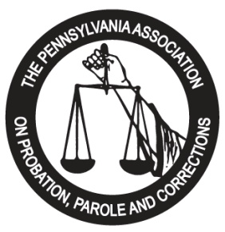

This serves as the contractual agreement between the Pennsylvania Association on Probation, Parole and Corrections (PAPPC), and your agency. PAPPC agrees to provide exhibit space and/or advertisements for your company at the 2020 Training Institute to be held at the Hilton Hotel, 1 North Second Street, Harrisburg, PA-- May 17th through May 20th, 2020, according to the specifications listed below:

Exhibit Booth: $ 525.00* ______________

INTERNAL USE ONLY

DATE RECEIVED:
__________________

BOOTH NUMBER:
__________________
$ 575.00** ______________
Program Journal Ad:
-Full page: $ 200.00 ______________
-Half page: $ 100.00 ______________
-Quarter page: $ 50.00 ______________
-Rear Cover $ 700.00 ______________
Sponsorships (see attached) ______________
Total: ______________

Authorized Signature: Date:

Please PRINT:
Name/Title
* Exhibitor Registration postmarked and payment received on or before April 9, 2020
** Exhibitor Registration postmarked and payment received on or after April 10, 2020

All checks should be made payable to: PAPPC
Please complete below information, as you would like it to appear in our conference program.

Company Name:

Forward Registration Forms, Checks and Electronic Ads to:

2020 Exhibitor Chair
Darrell Kirkbride/PAPPC
P.O. Box 5553
Harrisburg, PA 17110

Address:

Phone Number: Fax Number:

Representative(s):

E-Mail Address:

Product Line/Services:

DO YOU REQUIRE ELECTRICITY FOR YOUR BOOTH? __Y __N *Please note that electrical use/fees are set by the Hilton Harrisburg Hotel at $25 per table. If you require the use of electric, you must complete the enclosed electric form and return, completed in full, with the remainder of packet, to the address listed on this page.

